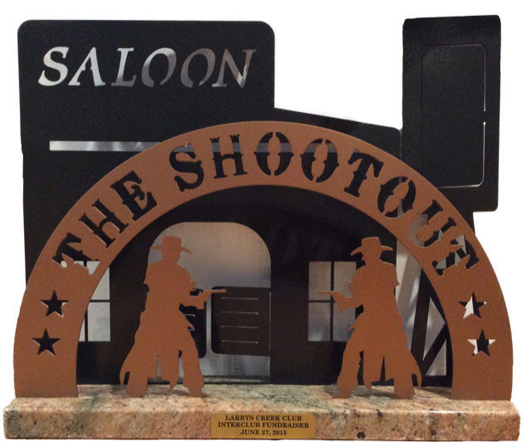Donation Form
I, _____________________________________,
am proud to donate $___________ to the
Pennsylvania Wounded Warriors Inc.
For this generous donation of $1000 or more, a 4x6 billboard will be custom made (as shown below) and placed on display at The Shoot Out on Saturday, June 22nd, 2019.

Please list the name of the person or business that you would like displayed on the billboard. Also email a high-resolution digital logo to theshootout.dlr@gmail.com.

Please make checks payable to:
Pennsylvania Wounded Warriors Inc.

Mail checks to:
Theresa Roupp
12308 Rt. 287 Hwy
Trout Run, PA 17771

